Technical Evaluation

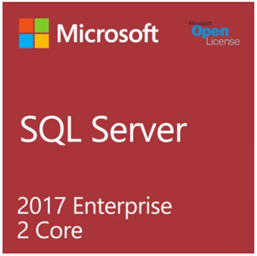Microsoft SQL Server 2017 Enterprise 2 Core

* Take advantage of high-level scalability, performance, and availability for query run time complexity, intelligent applications and data warehouses.
* Protect data at rest and in motion with the least vulnerable database over the last seven years in the NIST vulnerabilities database
* Gain transformative insights for your business with real-time analytics at up to 1M predictions/second. Queries will be 100 times faster.
* Turn raw data into meaningful reports that can be delivered to any device—at one-fifth the cost of other self-service solutions.
* Microsoft SQL Server 2017 Enterprise can provide organizational compliance and security with built-in security and IT controls

Informatica PowerCenter

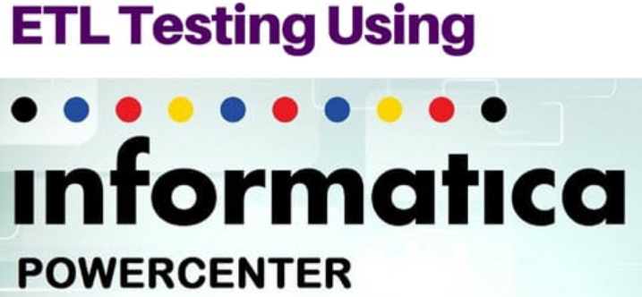

* Informatica PowerCenter is a widely used extraction, transformation and loading (ETL) tool used in building enterprise data warehouses
* With its high availability as well as being fully scalable and high-performing, PowerCenter provides the foundation for all major [data integration](https://www.alooma.com/blog/what-is-data-integration) projects
* Informatica PowerCenter enables access to almost any data source from one platform.
* This ETL tool makes it possible to simplify the development of data warehouses and data marts

Cost Evaluation

Microsoft SQL Server 2017 Enterprise 2 Core: $14,999

* Enterprise Edition runs on Windows Operating System
* Enterprise Edition provide high performance and support up to 524,000 TB of data
* Enterprise Edition support multi licensed for Home and Commercial use

Informatica PowerCenter Premium Edition: Starting at $2,000 (per month)

* Premium Edison include data migration and warehousing
* Premium Edison support real time Advanced Transformation
* Premium Edison support Master Data Management (MDM)

Risk Matrix

|  |  |  |  |
| --- | --- | --- | --- |
| **Variable** | **Low** | **Medium** | **Red** |
| **Technology** | Expert level – has cloud 24/7 support | Minimum experience – support is basic | Little to no experience – no budget to acquire high level tech. support |
| **Complexity** | Minimal impact | Moderate impact | Extensive impact |
| **Integration** | Extensive integration - all systems properly integrated | Limited integration | No integration - No budget to acquire properly integrated software |
| **Organization** | Solid internal support - Team is properly organized | Support to an extent - support is basic | Low internal support - no budget to hire experienced personnel |
| **Project team** | Business experience – diverse level of knowledge | Some business experience – moderate level of experience | No business experience – no budget to hire higher experienced personnel |
| **Financial Investment** | ROI within short time | ROI within moderate time | ROI after a few years |
| **Time** | Adequate time - Enough time to properly implement and test all systems | Moderate amount of time - Systems can be implemented but short testing period | Short time - not enough time to adequately implement and test all systems |

Work Citied:

SQL Server:

<https://www.mychoicesoftware.com/products/microsoft-sql-server-2017-enterprise-2-core-open-license?utm_medium=cpc&utm_source=googleshopping&dfw_tracker=45727-11475792135&gclid=Cj0KCQjwhtT1BRCiARIsAGlY51JRmaCsJ2wKnQ3VW3dsqS6NIE9VLnJUVq6sBQL95fZYv2RzkIPDIfoaAp4iEALw_wcB>

Informatica PowerCenter:

https://www.alooma.com/answers/what-is-informatica-powercenter